healthy campus
Post-Training Walkthroughs for Practitioners
Three hands-on exercises to complete after your practitioner training: (1) clear a student, (2) document a service, and (3) complete your provider profile.

Before You Begin
Practice the first two walkthroughs in the demo, then complete the third in your real account when you are ready.
- Demo (practice): demo.healthycampus.com — a separate sandbox where every student is simulated. Nothing goes live and no emails are sent. Use it for Walkthroughs 1 and 2.
- Live (real): platform.healthycampus.com — your actual account. Walkthrough 3 (your provider profile) must be done here with your own login, not the demo.

Demo login (Walkthroughs 1 & 2):
Environment | Demo
URL | demo.healthycampus.com
Username | practitioner
Password | Admin@123

A note on student data
The demo students are simulated, so practice as much as you like.
In your live account you are working with real student information — follow your organization’s privacy and data-handling policies.

Walkthrough 1 — Clear a Student
Clearance happens on the student profile, and a student’s clearance color tells you where they stand: red = not cleared, yellow = Consent to Treat obtained (the minimum), green = fully cleared.

Steps
- Find the student from your dashboard. The student lookup sits right on the dashboard — search by name, student ID, or birth date in the top-left search bar.
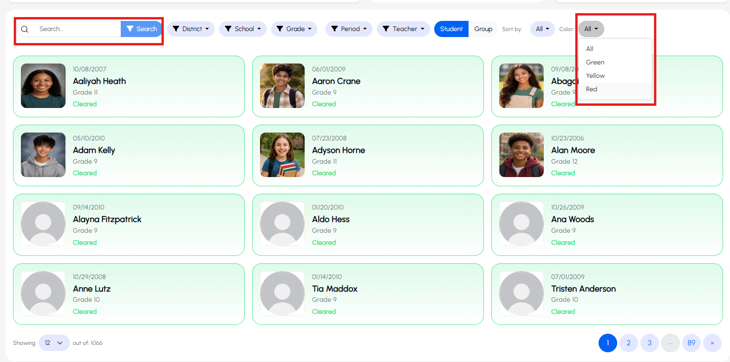
- Filter for uncleared students. Use the clearance-color filter in the top right and choose Red to list everyone still uncleared, then click a name to open their profile.
- Scroll to the student clearance card. In the demo you’ll see three clearance areas.
- Open a consent. Consent to Treat and Consent to Bill use the same process. Next to a consent marked Pending, click the Pending button.
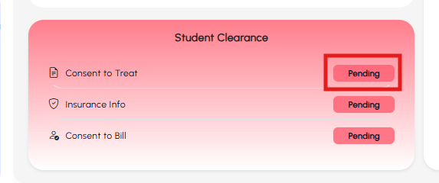
- Attest to self-consent. If the student is old enough to self-consent, a prompt appears with two checkboxes: the first attests the minor is self-consenting; the second attests they are not (a parent or guardian is consenting) — the more common choice. Select the one that applies and submit.
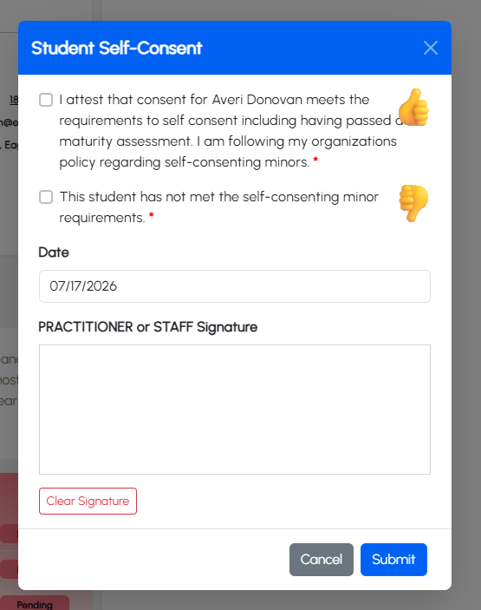
- Add the consent document. You have three options:
- Upload paper form — scan or photograph the signed form, browse to the file, add a quick signature to certify it uploaded correctly, check the box attesting an authorized parent/guardian completed it, then enter your name and the date of consent.
- Print & complete — print a blank consent for signing.
- Complete digital form with parent/guardian — displays the consent on your screen so the parent/guardian can read it, sign, enter their name and date, and submit electronically.
Why the consent date matters
The date of consent goes into the system. For Consent to Treat especially, it determines when the student becomes eligible to be billed for services.
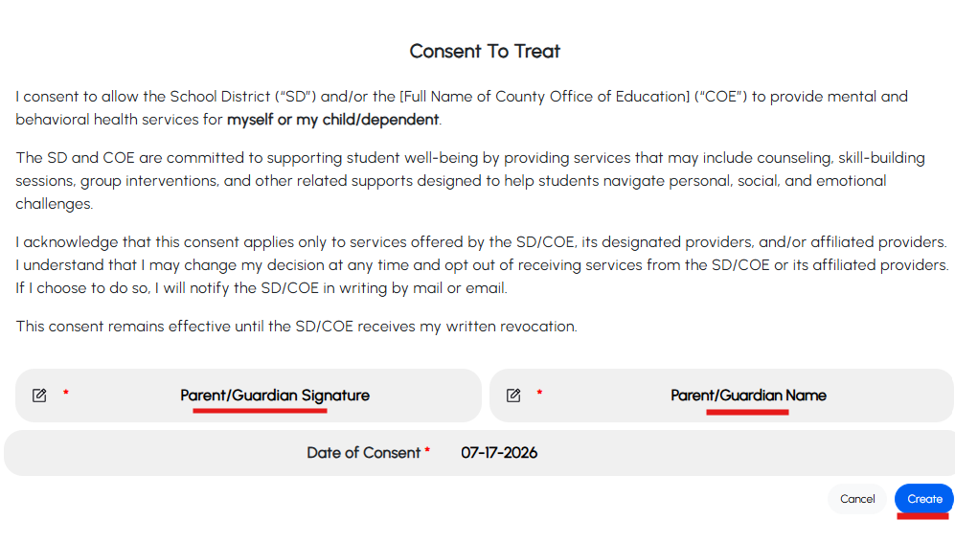
- Repeat for Consent to Bill. The steps are identical — upload a signed file or sign electronically.
- Add insurance. Click the Insurance status on the clearance card; it opens the Overview tab. On the right, under Insurance Information, you can view, update, or deactivate existing insurance — or click Add New.
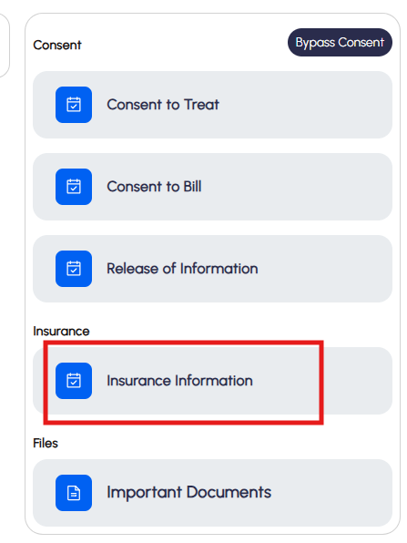 | 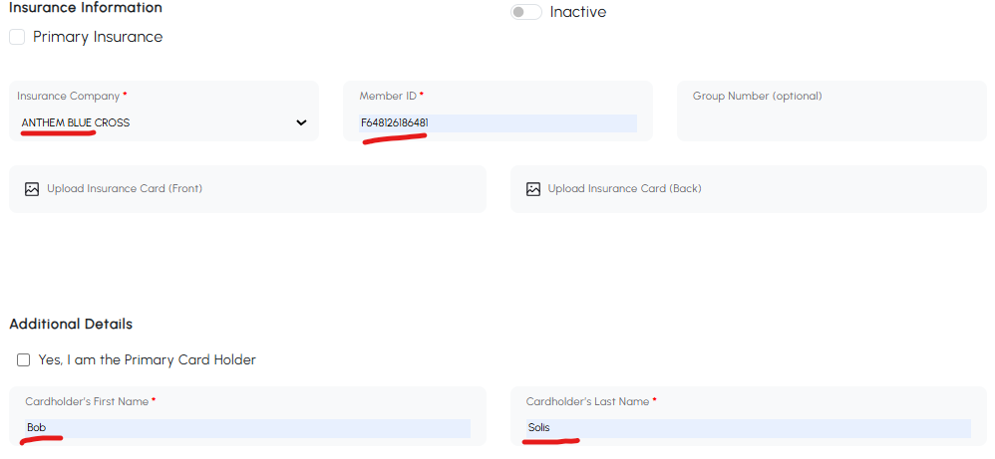
- Enter the insurance. Only four fields are required: insurance company, member ID, and the cardholder’s first and last name. Other fields help but aren’t required (a copy of the card is appreciated by billing but optional). Check the Primary insurance box if this will be the primary going forward, then Submit.
- Watch the color change. Once Consent to Treat is in, the student turns yellow — the minimum. Without Consent to Treat they stay red no matter what else is done. Completing insurance and Consent to Bill turns them green: fully cleared.
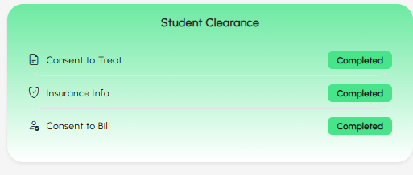
If the student is self-consenting
The flow is the same, except the system asks for the student’s signature (their name is pre-populated). Minors can self-consent for both treatment and billing.

Walkthrough 2 — Document a Service
Documenting happens inside a session on the student profile.

Steps
- Pick a student — not the same one as everyone else. The default people tend to pick is Aliyah Heath (first on the list). Instead, search your own first name; if that student isn’t cleared yet, clear them first (Walkthrough 1). All demo students are simulated.
- Start a walk-in visit. Open the profile and, from the Check-in screen (not the clearance card), choose Walk-in Visit.
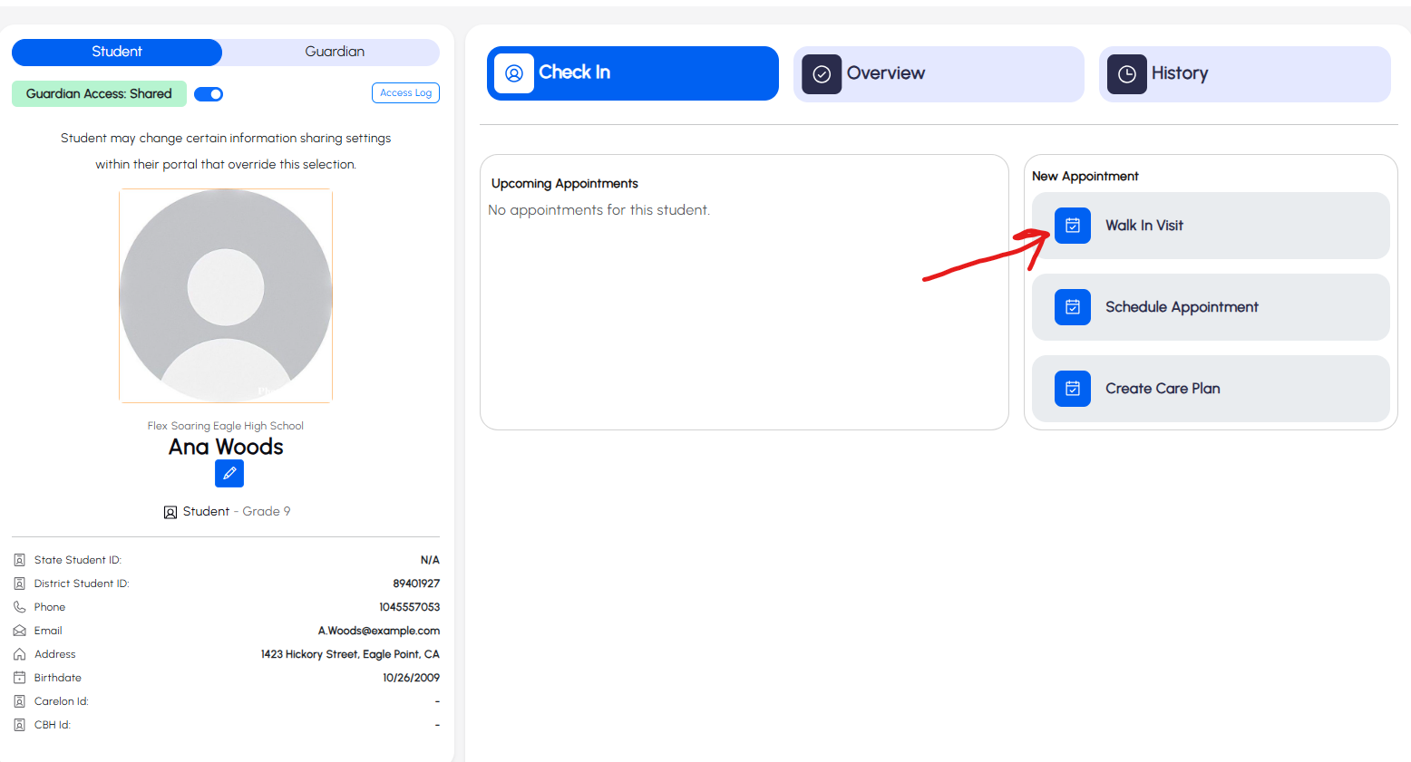
- Review the session screen. A timer runs automatically at the top (you can adjust it later). There’s also a “written in the student’s IEP?” toggle that defaults to No — choosing Yes is fine, but those services won’t bill under CYBHI.
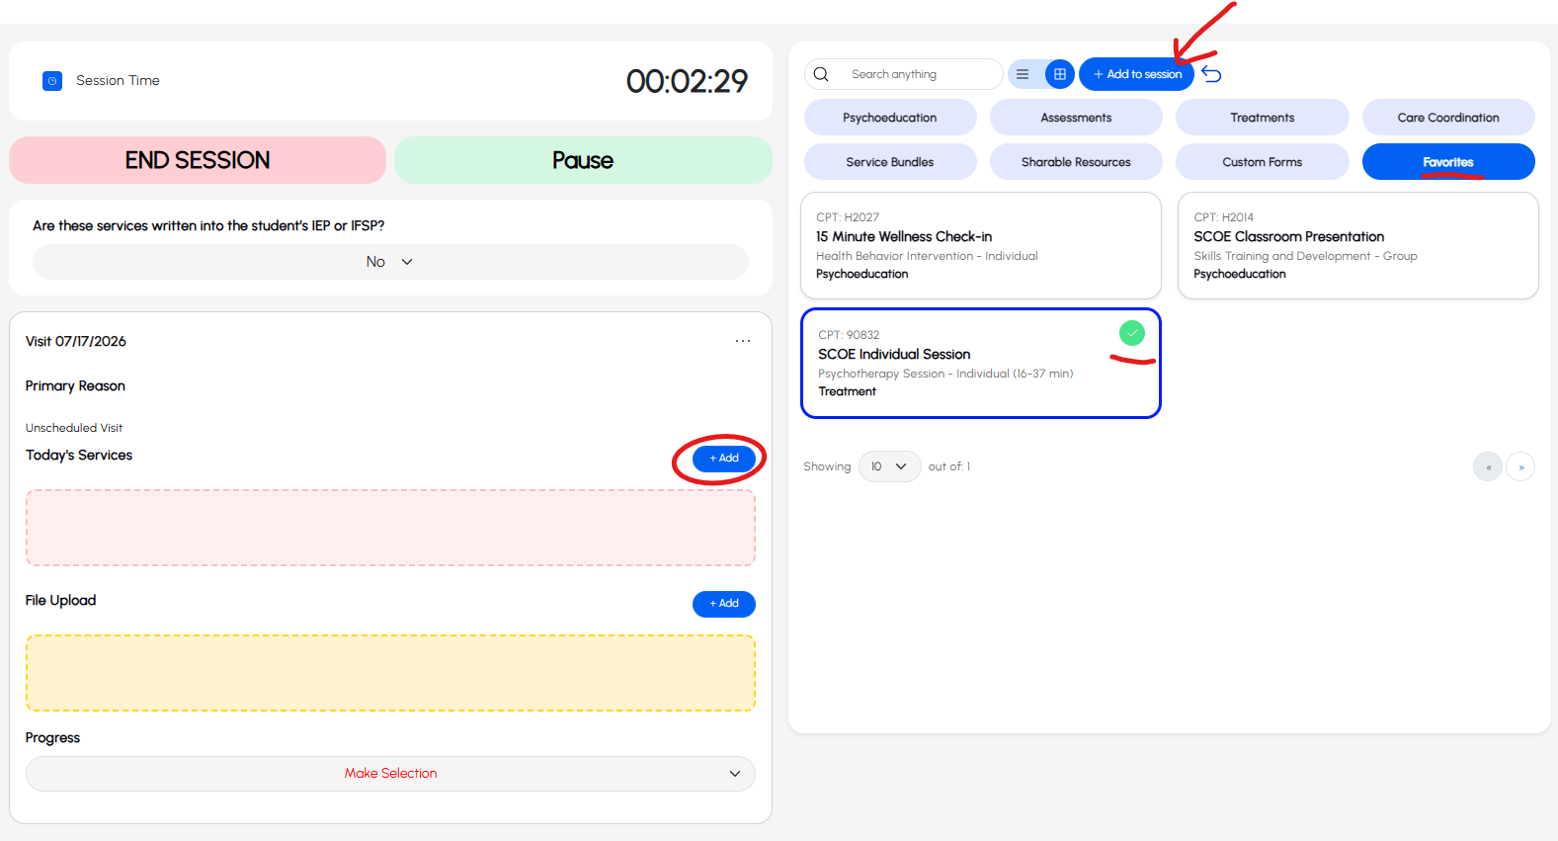
- Add services. Click the blue Add button next to Today’s Services. The menu on the right shows only the services you’re eligible to provide based on your practitioner type — a PPS counselor sees different services than a wellness coach, and so on. The Favorites list is worth a look too.
- Select and add. Click the services you want (they highlight blue with a green checkmark), then click Add to Session at the top of the menu. They’ll appear on the left.
- Fill out the form. Click a service on the left and its form template opens on the right. Complete the required fields — these are set by your supervisors and admins, not something you configure. Scroll down and click the blue Complete button to save that service in the session.
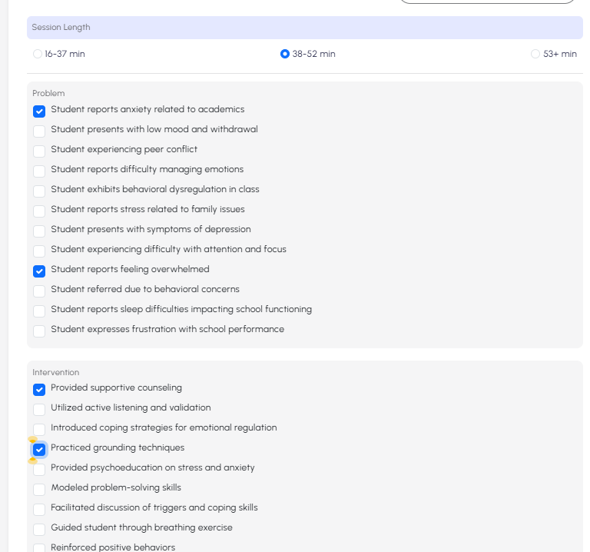
- Add more if needed. You can document multiple services in one session. Bundles make repeat combinations faster — ask your admin to set one up if you use the same set often. You can also upload files (handwritten notes, paper assessments) and optionally indicate the student’s progress.
- End the session. Click the red End Session button. You don’t have to run this live during the visit — afterward you can adjust the start time, end time, or date, confirm the services delivered, make last changes, and sign.
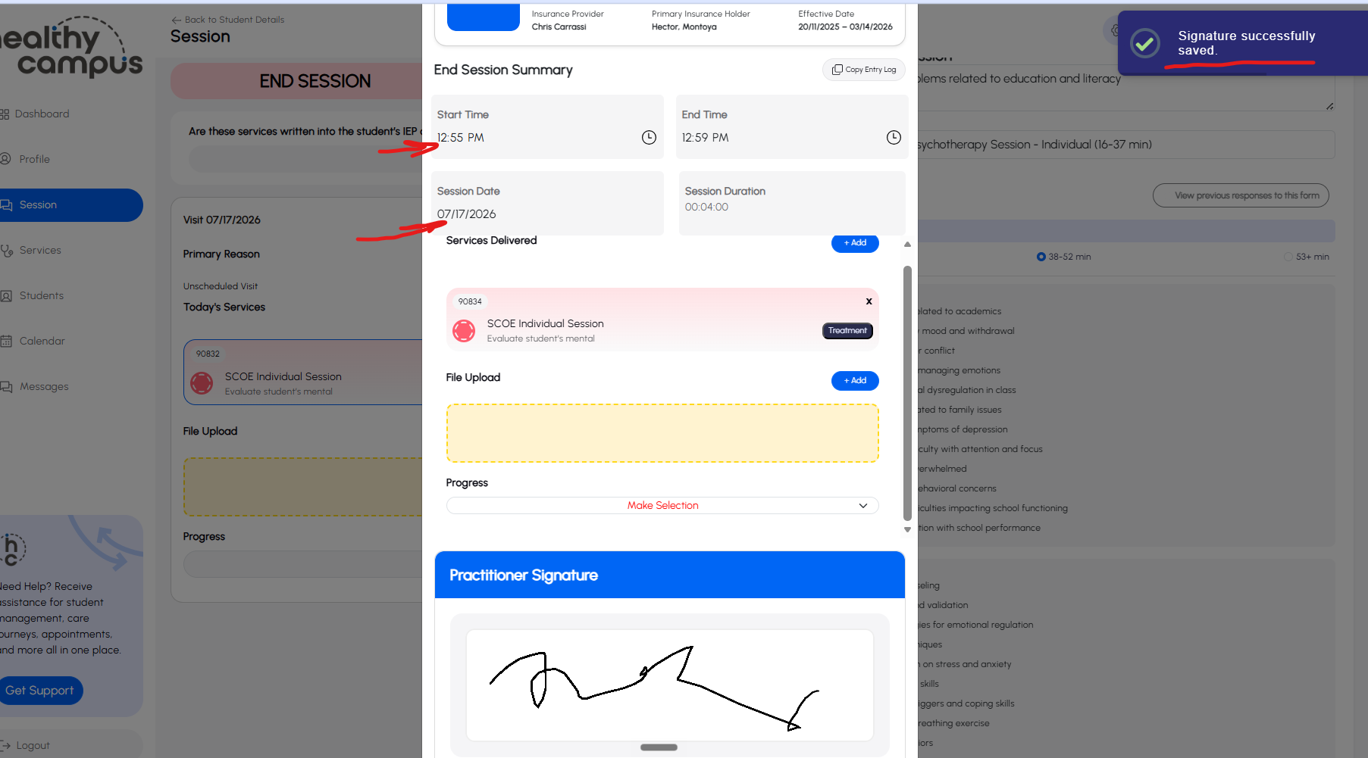
- Confirm. Once you hit Confirm you’re done — the service is automatically routed to the Healthy Campus billing team to evaluate for billing.

Walkthrough 3 — Complete Your Provider Profile
Do this one in your live account — not the demo
Complete your profile at platform.healthycampus.com using your own login. You can’t check in any students until your profile is complete.

Steps
- Open your profile. In your live account, go to the Profile tab. Your basic info (name, email) appears at the top left — click the blue View/Edit button beneath it.
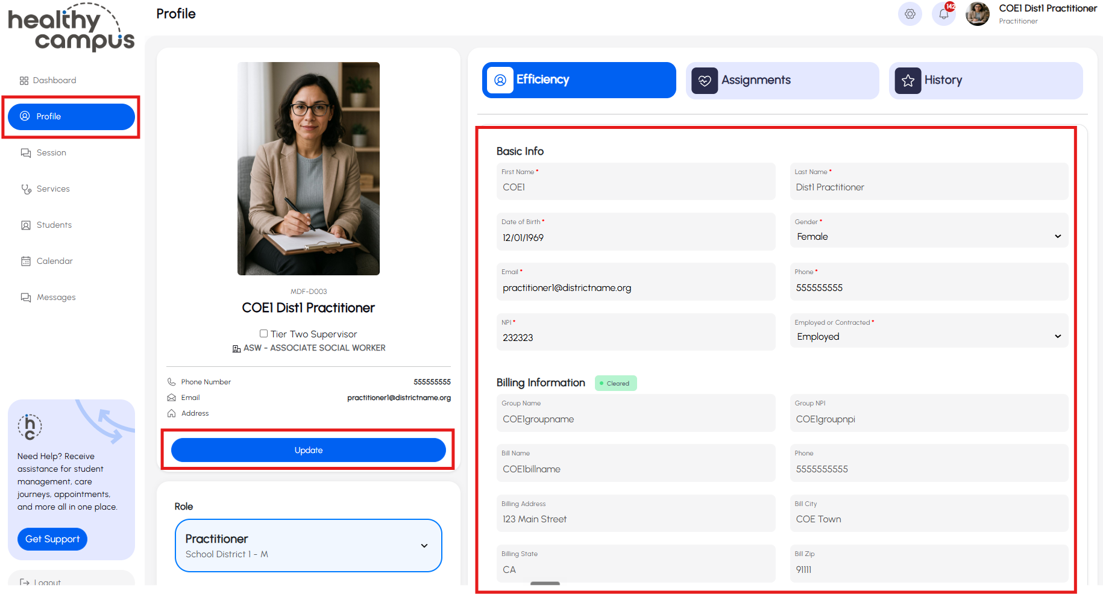
- Confirm your Basic Info. Some fields (first/last name, email, maybe phone or gender) may be pre-filled. Confirm everything is correct — including your date of birth, since a pre-populated value may just be a placeholder. All basic info is required, including your NPI.
NPI (the National Provider Identifier)
This is your 10-digit NPI. If you don’t have one, Healthy Campus can point you to resources — it’s free to obtain and required for the program.
- Skip Billing Information. You don’t need to touch this — your admin team and the Healthy Campus team complete it.
- Complete your License Information. This is the part with the most questions:
- Primary degree (required) — this is the payer’s term for your practitioner type, not the degree you earned in college. The dropdown includes options like psychiatrist/MD, LCSW, LPCC, LMFT, ASW, ACSW, PPS school counselor, wellness coach, and community health worker. Pick the closest fit; ask your admin if you’re unsure.
- License / credential number — depending on your primary degree, you may be required to provide this. If licensed: license number, issuing state, effective date, and expiration date. If PPS-credentialed: your credential number. The right fields appear based on your primary degree.
- Provider specialty (required by payers) — a long list. If you have a specialty, choose it. If you’re unsure, two that partners commonly select are mental health and school-related problems (confirm the exact entry in the dropdown).
- Provider ID / Medi-Cal ID — leave these blank. They come back after your information is submitted to Carelon. Leave your SSN blank – we don’t need it!
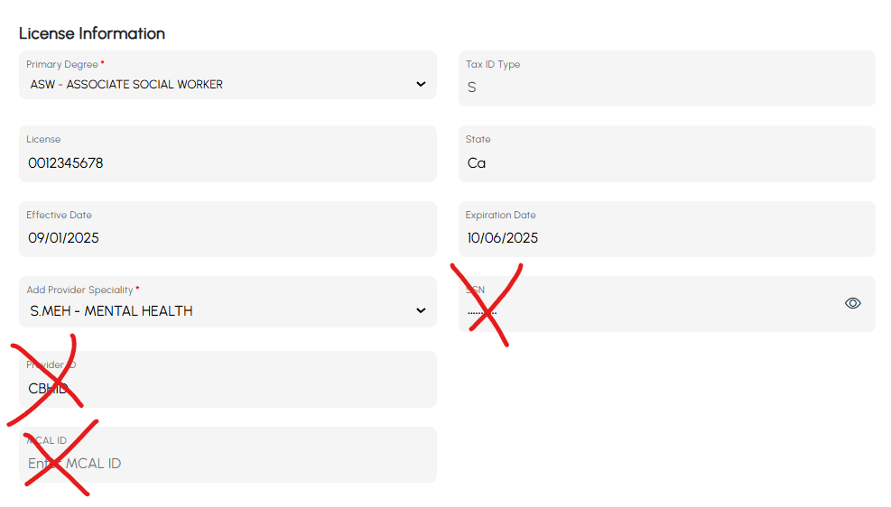
- Save. Scroll back up and click the Update tab. A “Profile information saved” message appears in the top right. You’re set and can begin documenting services in your live account.

